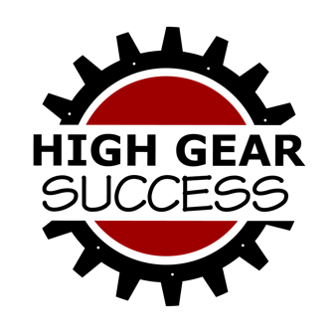

**Media Contact:**

Heather Wilson

Heather@HighGearSuccess.com

FOR IMMEDIATE RELEASE

August 10, 2021

**Heather Wilson Launches Motorsports Communications and Marketing Company**

Former AMA Director of Member Activity seeks to help businesses, event organizers and riders get noticed

**Pataskala, Ohio –** With more than 10 years of experience in the motorsports industry and the desire to make an impact, Heather Wilson has started a new venture. High Gear Success was established to help motorsports businesses, event organizers and racers to get noticed and make more money.

Services include:

* **Content Creation:** website/blog copy, feature stories, email campaigns and social media management
* **Event Planning & Promotion:** event playbook and timeline
* **Public & Media Relations:** press releases and pitching for media opportunities/podcast interviews
* **Strategy:** messaging, engagement opportunities, program development, strategic partnership planning and sponsorship

“I’ve been riding motorcycles since the age of 5 and have enjoyed contributing my communications and marketing expertise to an industry I’m passionate about,” said Owner of High Gear Success Heather Wilson. “My prior roles and experience have given me insight into the industry and the challenges that businesses, event organizers and riders face. I want to shift those struggles into success.”

Wilson’s involvement in the industry has allowed her to understand various segments of on- and off-road recreational riding and racing, as well as volunteer, fan and customer engagement. As a rider and strategist, she recognizes marketing opportunities for dealerships, event organizers, manufacturers and aftermarket companies. She then develops and executes a strategic plan of action.

Wilson spent nearly 7 years at the American Motorcyclist Association in Pickerington, Ohio, most recently as the Director of Member Activity. Prior to her time at the AMA, she was the Communications Specialist at the Motorcycle Industry Council in Irvine, Calif.

She grew up in motorcycling, as her parents established Wheelsports, a motorcycle dealership in central Ohio in 1977, and still own and operate it today. The family spent most weekends camping and riding motorcycles together or at enduros serving as pit crew for her dad, a former ISDE Trophy Team rider during the 80s.

Wilson’s current garage includes a KTM Freeride 250R dirt bike and a KTM 690 Duke for the road. She also serves as a chief trainer for Motorcycle Ohio, the motorcycle safety program operated by the state, as well as being a Motorcycle Safety Foundation-certified instructor.

She holds a Bachelor of Science in Journalism from Ohio University, with specializations in public relations and marketing. She also earned a minor in organizational communications and a professional sales certificate.

**About High Gear Success**High Gear Consulting LLC DBA High Gear Success is a motorsports communications and marketing strategy company located in Pataskala, Ohio, that seeks to help motorsports businesses, event organizers and riders get noticed and make more money. Fueled by passion, Heather Wilson, CEO, focuses strategies on engagement and awareness in order to drive results. Learn more at HighGearSuccess.com or on social media at facebook.com/highgearsuccess, Instagram.com/highgearsuccess or twitter.com/highgearsuccess.